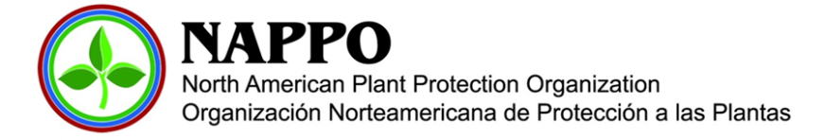
12 May 2022
Dear Colleagues and Stakeholders,
This year marks the North American Plant Protection Organization’s (NAPPO) 46th anniversary. During this time, NAPPO has served as a forum for government, industry, and other plant health stakeholders to work towards the harmonized protection of the plant resources of Canada, the United States, and Mexico. NAPPO is recognized by the International Plant Protection Convention (IPPC) and is named in the newly ratified Canada, United States and Mexico Agreement (CUSMA), United States, Mexico and Canada Agreement (USMCA), or Tratado entre Mexico, Estados Unidos y Canada (T-MEC).
NAPPO is unique in the international plant protection community because it is the only regional plant protection organization (RPPO) that fosters robust government-industry cooperation, with industry input playing a vital role in the design and implementation of regional plant health standards that promote safe trade. Additionally, NAPPO regional standards have helped shape important international standards developed under the IPPC. Examples include standards for wood packaging, international movement of seeds, pest-free areas, and areas of low pest prevalence, among others. NAPPO’s close collaboration with other RPPOs and international organizations also contributes to global standard-setting initiatives.
Throughout NAPPO’s evolution and heading into the future, our core strategic goals remain unchanged:
- Protect all North American plant resources, including natural ecosystems, from the introduction and spread of regulated plant pests;
- Facilitate safe trade on the basis of science-based regional standards and harmonized phytosanitary measures;
- Promote and maintain active industry and stakeholder engagement in NAPPO activities;
- Contribute leadership in the international phytosanitary community (including engagement with the IPPC, RPPOs and other international organizations);
- Promote and maintain the scientific and technical basis of NAPPO activities, and
- Continue improving NAPPO communication and outreach.

These goals are reflected in the enclosed draft NAPPO Strategic Plan for 2022 to 2026. The plan details how NAPPO will pursue these goals as it faces key challenges and opportunities over the next five years. Working regionally, cooperatively, and transparently, this strategic plan will help NAPPO meet our goals in this challenging and dynamic environment.

Sincerely,
Signature - Greg Wolff, EC member for Canada
Signature - Ibrahim Shaqir, EC member for the United States
Signature - Francisco Ramirez y Ramirez, EC member for Mexico

